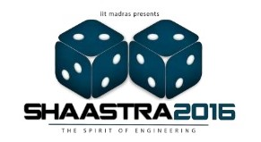
FRESHIE PROJECT X
PROBLEM STATEMENT

Here’s a chance to show off your aiming skills……….get going and try your hard at this “strike”……. Build a self-standing kicking model to kick the given ball (ping pong ball) into our miniature goal post.

Materials given:
- 10 Ice-cream sticks
- 4 Rubber bands
- 1 Pencil
- 1 Cutter
- 1 Thread roll

Instructions:
1. Each team can contain a maximum of 3 members.
2. Each team will be given 3 kicks.
3. The dimension of the goal post is 10cm X 20 cm.
4. The model has to be kept behind the primary line which is 200 cm away from the goal post.
5. While scoring goal the participant may hold the base of the model with one hand and kick the ball with the other.
6. Each team will be given 2 hours for designing their model.

Scoring:
- For each goal 10 points are awarded.
- If the ball touches the goal post and no goal is scored then 5 points will be awarded.
- If there is a tie, then there will be a second round to decide the winner.
** THE DECISION OF THE COORDINATORS IS FINAL AND BINDING.

